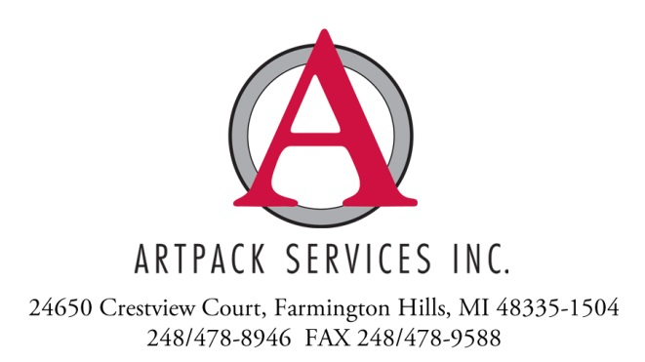
IN PERSON APPOINTMENT SAFETY AGREEMENT

Artpack Services Inc. is abiding by the guidelines put forth by the Art Service Workers Safety Coalition to provide protections to all parties during in-person appointments.

In advance of our representative’s visit to your location, we affirm that our staff has been trained on proper social distancing guidelines and will be prepared with personal protective equipment (PPE) in the form of face coverings, latex or nitrile gloves and hand sanitizer. It is our expectation that the reciprocal efforts outlined below be made by you and your staff to ensure the safety of all parties.

- You and your immediate staff will be prepared with personal protective equipment (PPE) in the form of face coverings, latex or nitrile gloves and hand sanitizer.
- Contractors or vendors at your location that our representatives will be in close proximity to will also be prepared with personal protective equipment (PPE). If they are not then we ask that they are required to vacate the immediate area for the duration of our representative's visit
- In the event that you or someone on your immediate staff is unprepared, our representative will provide a small, sealed PPE kit (1 face covering, 1 pair of latex gloves). Depending on the circumstance you may be responsible for the cost of these items
- When applicable, all artworks or objects to be viewed/collected will be staged in advance in a sanitized, well ventilated area with adequate space for proper social distancing to be observed
- If you do not have adequate space, we ask that you inform us in advance so that additional PPE (plastic face shields) can be provided, or an alternative plan for viewing and/or packing of objects can be arranged
- If signatures are required on paperwork, you will provide your own writing utensil or agree to an electronic exchange of signatures via email
- You will inform us immediately in the event that someone at your location, either before or within 14 days of our visit, is exhibiting known symptoms of COVID-19.

- If you or your organization require additional safety measures above what we have in place, we ask that you inform us well in advance of our visit so that preparations can be made

If situations arise that are deemed detrimental to our representative's safety, we reserve the right to postpone or cancel the visit until the appropriate safety measures can be put in place.

